Week 12
Top K Frequent Elements
import java.util.*;
class Solution {
public int[] topKFrequent(int[] nums, int k)
HashMap<Integer, Integer> map = new HashMap<>();
for (int num : nums) {
map.put(num, map.getOrDefault(num, 0) + 1);
}
List<Integer>[] bucket = new List[nums.length + 1];
for (int num : map.keySet()) {
int freq = map.get(num);
if (bucket[freq] == null) {
bucket[freq] = new ArrayList<>();
}
bucket[freq].add(num);
}
int[] result = new int[k];
int index = 0;
for (int i = bucket.length - 1; i >= 0; i--) {
if (bucket[i] != null) {
for (int num : bucket[i]) {
result[index++] = num;
if (index == k) {
return result;
}
}
}
}

return result;
}
}
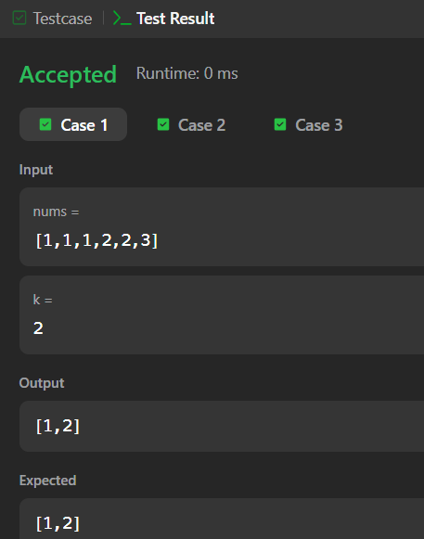
Group Anagrams
import java.util.*;
class Solution {
public List<List<String>> groupAnagrams(String[] strs) {
HashMap<String, List<String>> map = new HashMap<>();
for (String str : strs) {
char[] chars = str.toCharArray();
Arrays.sort(chars);
String key = new String(chars);
map.putIfAbsent(key, new ArrayList<>());
map.get(key).add(str);
}
return new ArrayList<>(map.values());
}
}
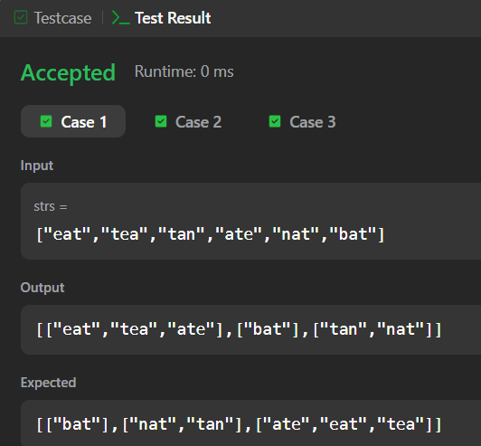

Top K Frequent Words

import java.util.*;
class Solution {
public List<String> topKFrequent(String[] words, int k) {
Map<String, Integer> map = new HashMap<>();
for (String word : words) {
map.put(word, map.getOrDefault(word, 0) + 1);
}
PriorityQueue<String> pq = new PriorityQueue<>((a, b) -> {
int freqA = map.get(a);
int freqB = map.get(b);
if (freqA != freqB) {
return freqA - freqB;
}
return b.compareTo(a);
});
for (String word : map.keySet()) {
pq.offer(word);
if (pq.size() > k) {
pq.poll();
}
}
String[] result = new String[k];
for (int i = k - 1; i >= 0; i--) {
result[i] = pq.poll();
}
return Arrays.asList(result);
}
}
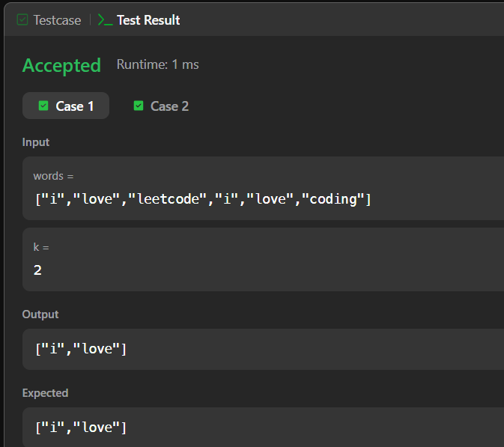
Design HashMap
class MyHashMap {
int[] arr;
public MyHashMap() {
arr = new int[1000001];

for (int i = 0; i < arr.length; i++) {
arr[i] = -1;
}
}
public void put(int key, int value) {
arr[key] = value;
}
public int get(int key) {
return arr[key];
}
public void remove(int key) {
arr[key] = -1;
}
}
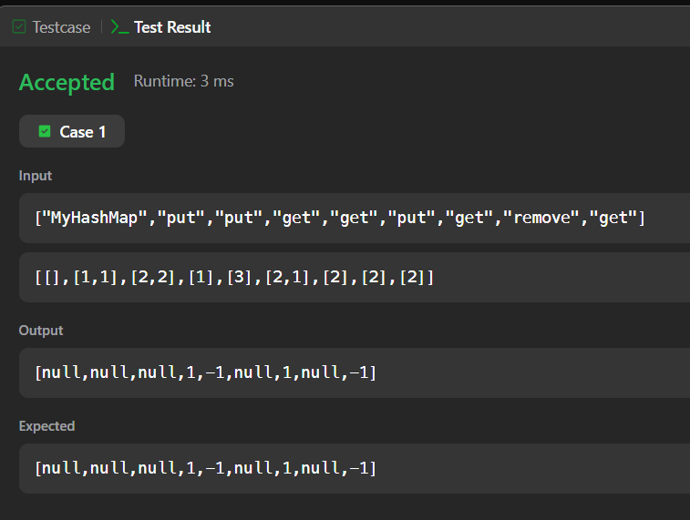

Design a Food Rating System
import java.util.*;
class FoodRatings {
Map<String, String> foodCuisine;
Map<String, Integer> foodRating;
Map<String, PriorityQueue<Food>> cuisineFoods;
class Food {
String name;
int rating;
Food(String name, int rating) {
this.name = name;
this.rating = rating;
}
}
public FoodRatings(String[] foods, String[] cuisines, int[] ratings) {
foodCuisine = new HashMap<>();
foodRating = new HashMap<>();
cuisineFoods = new HashMap<>();
for (int i = 0; i < foods.length; i++) {
String food = foods[i];
String cuisine = cuisines[i];
int rating = ratings[i];
foodCuisine.put(food, cuisine);
foodRating.put(food, rating);
cuisineFoods.putIfAbsent(
cuisine,
new PriorityQueue<>((a, b) -> {
if (a.rating != b.rating) {
return b.rating - a.rating;
}
return a.name.compareTo(b.name);
})
);
cuisineFoods.get(cuisine).offer(
new Food(food, rating)
);
}
}
public void changeRating(String food, int newRating) {
foodRating.put(food, newRating);
String cuisine = foodCuisine.get(food);
cuisineFoods.get(cuisine).offer(
new Food(food, newRating)
);
}
public String highestRated(String cuisine) {
PriorityQueue<Food> pq = cuisineFoods.get(cuisine);
while (!pq.isEmpty()) {
Food top = pq.peek();
if (top.rating == foodRating.get(top.name)) {
return top.name;
}

pq.poll();
}
return "";
}
}
